use John0The0Ripper to crack a password

"john/run/john" --incremental --format=raw-md5 pass.txt

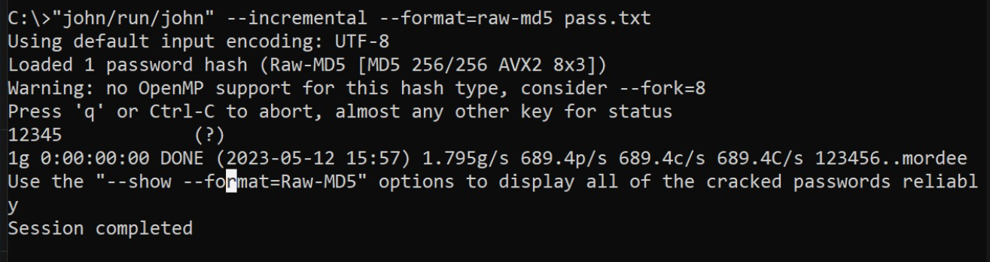

-How SQLMap works

mysql -u root -p

create database itidb;

use itidb;

create table course (cid int,cname varchar(50),cchour int);

create table user (uid varchar(30),upass varchar(100));

create user itiuser@localhost identified by 'itipass';

grant all privileges on itidb.\* to itiuser@localhost;

flush privileges;

insert into course (cid,cname,cchour) values (1,'intr to linux',3);

insert into course (cid,cname,cchour) values (2,'intr to app security',3);

insert into course (cid,cname,cchour) values (3,'intr to networks',3);

insert into user (uid,upass) values ('ahmed',md5('pass'));

insert into user (uid,upass) values ('ali',md5('pass'));

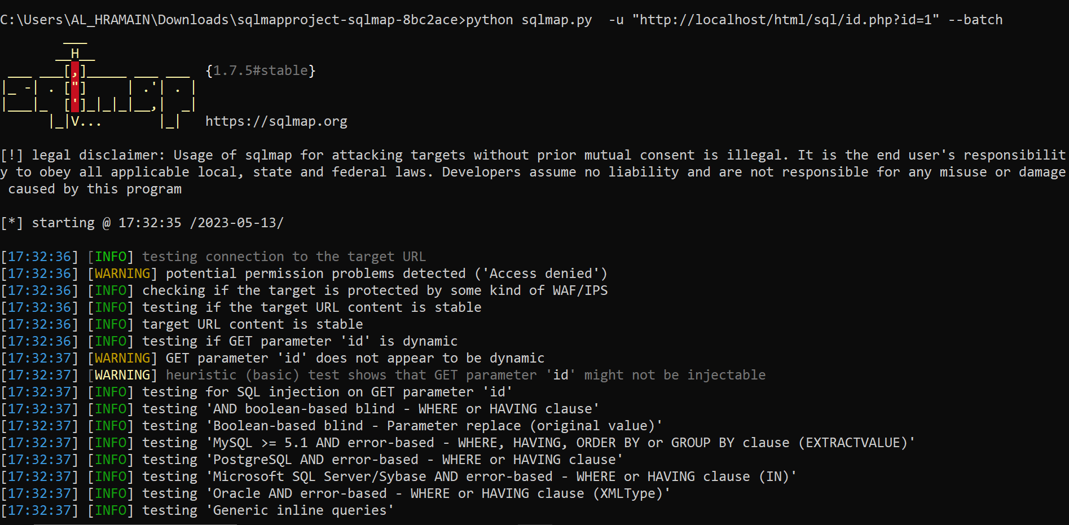

-List tables in a database

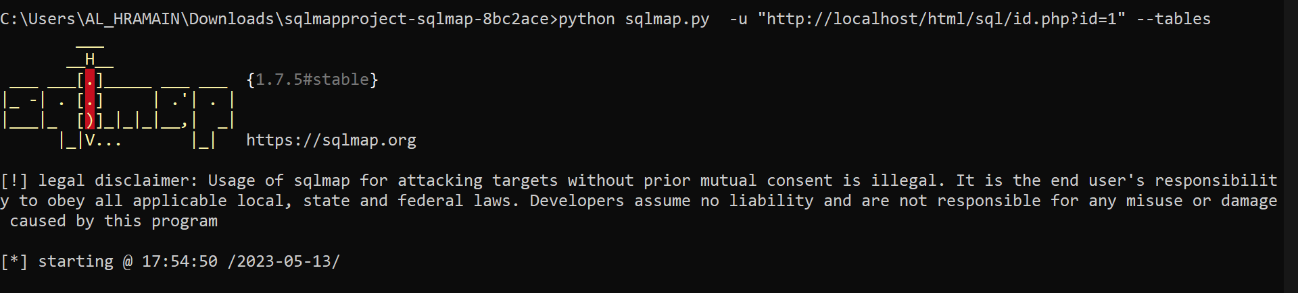

-Quer| all data in a database

